‘Z krosna do krosna’

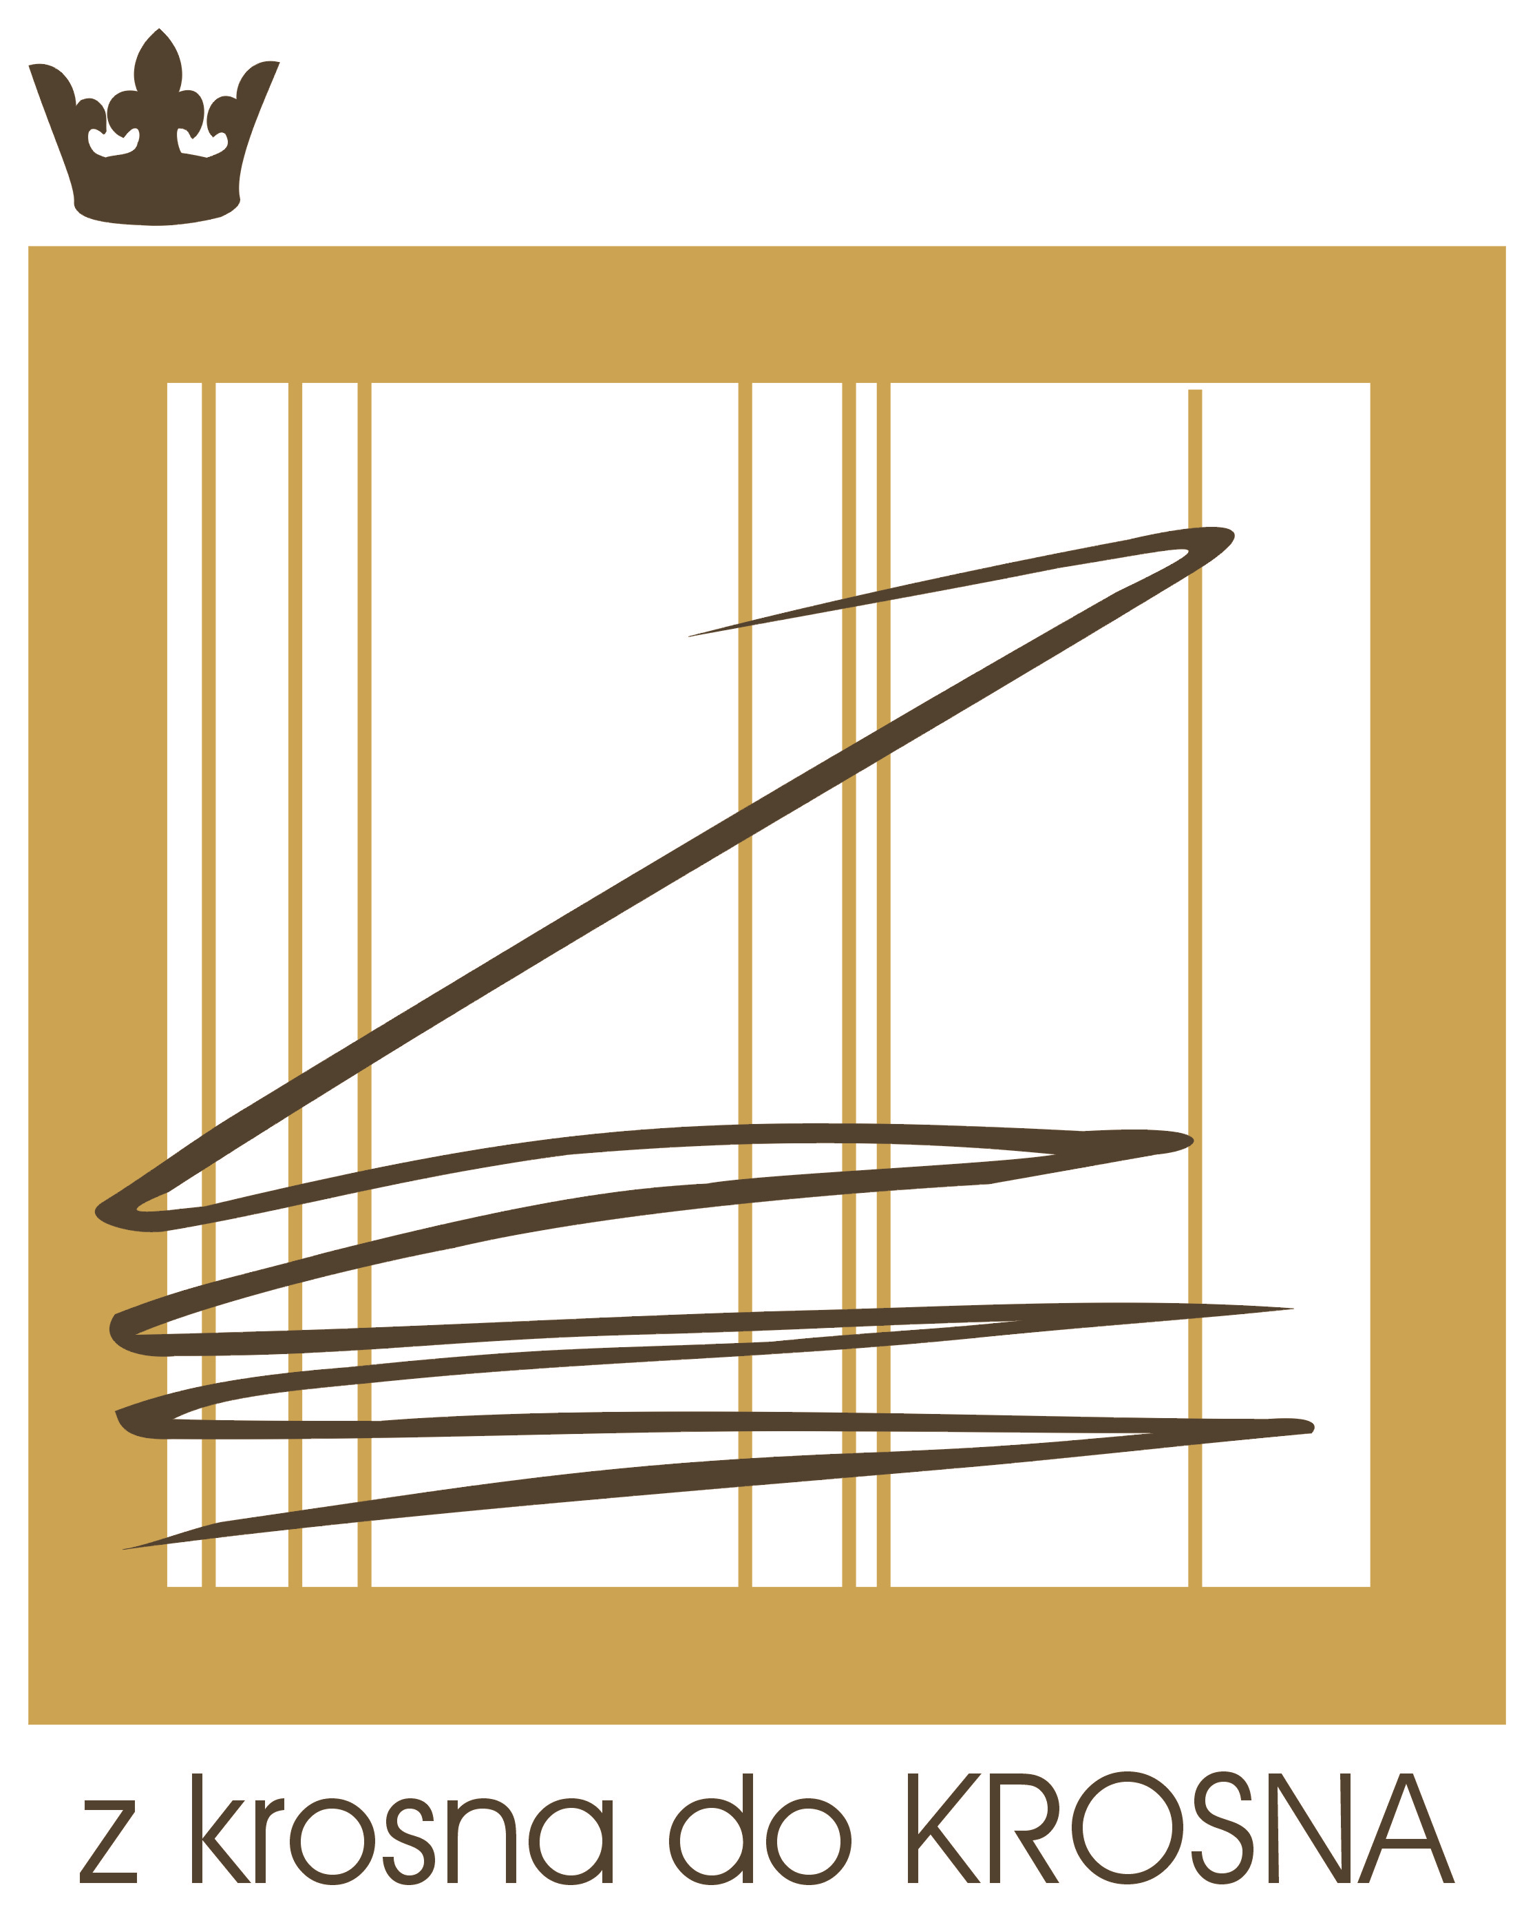
9th International Artistic Linen Cloth Biennial 2016

APPLICATION FORM
(Use block capitals)

Form NO 1: Personal details

FIRST and LAST NAME

ADDRESS

TELEPHONE

COUNTRY

E-MAIL

WEB SITE

A PERSONAL THOUGHT, SENTENCE, MOTTO

(to be published in the catalogue)

SHORT BIOGRAPHY (not more than 120 words)

‘Z krosna do krosna’

9th International Artistic Linen Cloth Biennial 2016

Form NO 2: Submitted artworks

TITLE | YEAR OF CREATION | TECHNIQUE | DIMENSIONS | AUTHOR'S PRICE  (PLN lub EURO) | I DONATE THE ARTWORK  (YES or NO)

- I hereby give my consent/ do not give my consent* for publishing my biography in the exhibition catalogue.
- The participation in the Biennial is synonymous with the consent of the Participants and the authors of photographs to the reproduction of the presented artworks and the photographs and publication of them in the media, free of charge as well as to process the personal data of Participants according to the Act of Law of 29 th August 1997 (Dz.U. 2014 nr 0 poz. 1182) about personal data protection,
- Donating the work Participant agrees to transfer proprietary copyrights to the Museum of Crafts in Krosno in the following fields of exploitation: a) the fixation and reproduction of the artwork, including printing, reprographic, magnetic recording and digital technique; b) circulation of the original or its copies bringing into circulation, exhibiting, lending or leasing the original or its copies; c) public sharing of the work in such a way that everyone can have access to it in any time and place individually chosen, including via the Internet.
- I hereby accept the rules and conditions of the Biennial and I bind myself to obey them.

......................................................................................
(Signature)
* Delete as applicable

